**AGENDA - Little Hoole Parish Council**

*Members of the Council are summoned to the Parish Council Meeting to be held on   
Mon 14th Oct 2024 at 7:00pm*

***The Lounge, Old Mill Court Retirement Housing, Liverpool Old Road, Walmer Bridge, PR4 5QU***Paul Cafferkey, Clerk & Responsible Financial Officer

1. Apologies for absence
2. To agree the Minutes of the last Parish Council Meeting
3. To receive declarations of interest
4. Matters arising from the minutes of last meeting
   1. Public Time: to invite and listen to issues raised by members of the public
   2. Planning Applications:
5. 07/2024/00703/DIS. Springfield Farm Knoll Lane Little Hoole PR4 4TB. Discharge of Condition No 7 (Method Statement) of planning permission 07/2024/00042/FUL
6. 07/2024/00704/DIS. Springfield Farm Knoll Lane Little Hoole PR4 4TB. Discharge of Condition No 7 (Method Statement) of planning permission 07/2023/01063/FUL
7. 07/2024/00668/FUL. Land Adjacent 26 Hall Carr Lane Walmer Bridge. Erection of 2 detached self-build/custom build dwellings.
8. 07/2024/00616/FUL. Lesser Marsh House Farm Station Road Little Hoole PR4 5LH. Retrospective Change of Use of Existing Barn from Agricultural Use into stables and erection of manege.
   1. To approve the following transactions in the bank for Aug and Sep 2024:   
      
   2. Payments for approval
      1. Clerk’s claim for Sep 2024
      2. Invoice for External Audit
   3. Payments approved by email or pre-approved and retrospectively noted
      1. To approve invoice for £244.76 for fixing & staining of planters.
   4. To approve financial statement as at 30 Sep 2024.
   5. AGAR (Annual Governance & Accountability Return 2023-24; External Auditor’s Report & Certificate: to note and approve the External Auditor’s Report & Certificate.
   6. Notice of conclusion of audit: to note and approve the Notice of conclusion of audit re AGAR 2023-24
   7. To discuss approve Internal Audit quote for 2024-25 Accounts.
   8. Donation Request from Walmer Bridge Village Hall
   9. To clarify responsibility for the administrative process for Councillor led projects.
   10. Discussion and proposal regarding Zip Line for Dob Lane Recreation Park.
   11. Discussion regarding the Parish Council purchasing rock salt for the winter period.
   12. To approve purchase of replacement Christmas Lights
   13. Remembrance Sunday Wreaths - update
   14. Winter Planting & Community Garden, discussion and proposal for purchase of winter plants.
   15. Correspondence
       1. Parish & Town Council Conference 2nd Nov 2024
   16. Information and Updates
   17. To agree the date, time, and venue for the Nov 2024 meeting.

**Members of the public are welcome to attend meetings to raise any relevant matters. Alternatively, if you cannot attend the meeting but wish to raise a matter or ask a question, this can be done on your behalf by contacting the Parish Clerk (Paul Cafferkey) via email at** [**clerk@littlehooleparishcouncil.org.uk**](mailto:clerk@littlehooleparishcouncil.org.uk) **or mobile phone 07966267186.**

Scan me to go the Little Hoole Parish Council Website, or visit <https://www.littlehooleparishcouncil.org.uk/>

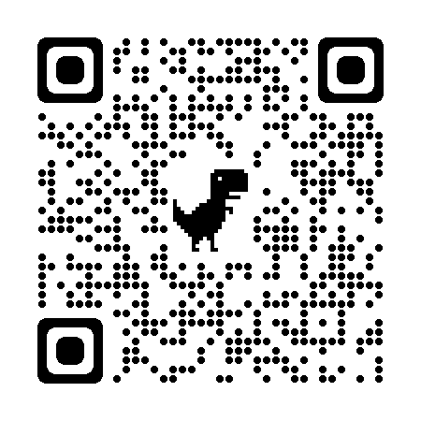

Prepared and approved by Paul Cafferkey, Clerk – Little Hoole Parish Council,   
9th Oct 2024